The Indian Mutiny
To regard the rebellion merely as a sepoy mutiny is to underestimate the root causes leading to it. British paramountcy—i.e., the belief in British dominance in Indian political, economic, and cultural life—had been introduced in India about 1820. The British increasingly used a variety of tactics to usurp control of the Hindu princely states that were under what were called subsidiary alliances with the British. Everywhere the old Indian aristocracy was being replaced by British officials. One notable British technique was called the doctrine of lapse, first perpetrated by Lord Dalhousie in the late 1840s. It involved the British prohibiting a Hindu ruler without a natural heir from adopting a successor and, after the ruler died or abdicated, annexing his land. To those problems may be added the growing discontent of the Brahmans, many of whom had been dispossessed of their revenues or had lost lucrative positions.
In the mid-19th century, British officers in northern India began to notice signs of disaffection, even intimations of rebellion, among the sepoys of the East India Company’s Bengal Army. They generally failed to realize the full significance of the unrest, however. Greater leniency by the British, such as abandoning flogging as punishment and decreasing the authority given regimental officers, seemed to have eroded the discipline of the sepoys. They had become dependent on strong leadership. More fundamentally, British reforms such as the ban on sutee, the self-immolation of widows, did not sit well with the Hindu sepoys, who felt that their customs and religion were being threatened.

When the British introduced a new Enfield rifle and a new greased-paper cartridge into the Indian Army, the distress within the ranks of the sepoys became acute.
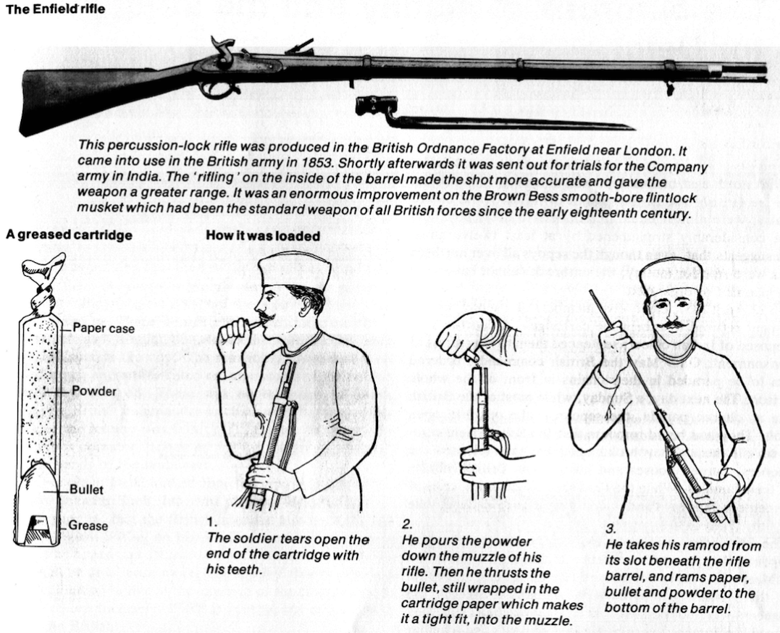
In February 1857, the 19th Native Infantry at Bahrampore in Bengal refused to accept the newly issued cartridges because, rumor had it, that they were greased with either pig or cow fat. Eating pig flesh was an abomination to Muslims, and the Hindu religion regarded the cow as sacred and therefore banned the consumption of its flesh. The British, realizing the problem, abandoned the use of meat fat for greasing, but the Hindu and Muslim soldiers still believed that their Christian commanders were trying to subject them to forbidden substances as a means of subverting their religion.
Another serious concern was the increasing pace of Westernization, by which Hindu society was being affected by the introduction of Western ideas. Missionaries were challenging the religious beliefs of the Hindus. The humanitarian movement led to reforms that went deeper than the political superstructure. During his tenure as governor-general of India (1848–56), Lord Dalhousie made efforts toward emancipating women and had introduced a bill to remove all legal obstacles to the remarriage of Hindu widows. Converts to Christianity were to share with their Hindu relatives in the property of the family estate. There was a widespread belief that the British aimed at breaking down the caste system. The introduction of Western methods of education was a direct challenge to orthodoxy, both Hindu and Muslim.
About that time, the British began to notice that Indian runners were crisscrossing much of northern India. When an Indian runner entered a neighboring village, he would pass on to someone — anyone — a chapatti, the flat, pancake like unleavened bread used throughout India. The recipient of the chapatti would then rush it to the next village and give it to someone there, and so on in a perpetual relay. Only in retrospect did the British understand that this was a way of alerting the populace that something momentous was about to occur.
More worrisome to the British was an isolated act of mutiny that erupted on March 19, 1857, on the parade ground of Barrackpore, near Calcutta. There, a zealot of the 34th Bengal Regiment named Mangal Pande suddenly broke ranks, shouting to his regimental mates: ‘Rise, all of you! The English are upon us; by biting the defiled cartridges, we shall all lose our religion!’ In an effort to restore calm, the regimental adjutant galloped into the melee, only to be cut down by the mutineer. The commanding general then dashed onto the parade ground and faced Pande, who pointed his gun at the general. Some stories relate that the general shouted defiantly, ‘Damn his musket!’ and, with his pistol aimed at Pande’s head, ordered the 34th to advance and seize the mutineer. Pande put his toe into the trigger of his musket and fired upward at his own breast. He survived his suicide attempt, only to be hanged by the British on April 8. The 34th was promptly disbanded as a result of this incident, but the legend of Mangal Pande lived on, gaining fervor with each retelling. His name would also live on in the nickname the British gave to the Indian mutineers — ‘pandies.’ Later in April sepoy troopers at Meerut refused the Enfield cartridges, and, as punishment, they were given long prison terms, fettered, and put in jail. This punishment incensed their comrades, who rose on May 10, shot their British officers, and marched to Delhi, where there were no European troops. There the local sepoy garrison joined the Meerut men, and by nightfall the aged pensionary Mughal emperor Bahādur Shah II had been nominally restored to power by a tumultuous soldiery. The seizure of Delhi provided a focus and set the pattern for the whole mutiny, which then spread throughout northern India. With the exception of the Mughal emperor and his sons and Nana Sahib, the adopted son of the deposed Maratha peshwa, none of the important Indian princes joined the mutineers.

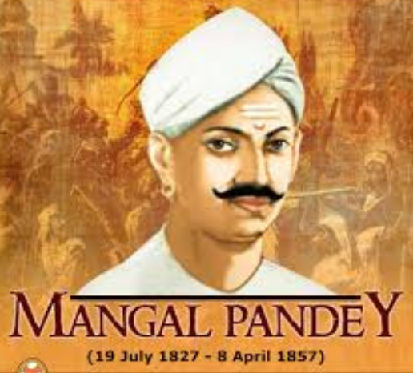
The mutiny broke out in the Bengal army because it was only in the military sphere that Indians were organized. The pretext for revolt was the introduction of the new Enfield rifle. To load it, the sepoys had to bite off the ends of lubricated cartridges. A rumour spread among the sepoys that the grease used to lubricate the cartridges was a mixture of pigs’ and cows’ lard; thus, to have oral contact with it was an insult to both Muslims and Hindus. There is no conclusive evidence that either of these materials was actually used on any of the cartridges in question. However, the perception that the cartridges were tainted added to the larger suspicion that the British were trying to undermine Indian traditional society. For their part, the British did not pay enough attention to the growing level of sepoy discontent.

By 1857, the Mogul dynasty had withered to the point of near extinction. The last of the Moguls, Bahadur Shah II, ‘King of Delhi,’ was a frail, opium-addicted old man deprived of any real power. A pensioner of the British, he was king in name only, and it was understood that upon his death his title would no longer exist.
Bahadur Shah’s keepers were British Commissioner Simon Fraser and a Captain Douglas, the commandant of the Palace Guards. Perched on the ridge overlooking Delhi were the British cantonments quartering the 38th, 54th and 74th Native Infantry and one battery of native artillery. By treaty agreement there were no British regiments there. This modest force was commanded by Brig. Gen. Harry Graves.
The royal palace housed some 12,000 retainers of one sort or another, who lived a generally unproductive existence. Nevertheless, they spawned countless schemes in the labyrinthine palace corridors to profit from their attachment to the throne. In the early hours of May 11, the king was jarred from his rest when news flashed through the court that the 3rd Native Cavalry from the nearby Meerut cantonment had dashed to Delhi and entered the city by the bridge over the Jumna River. Indeed, Bahadur could hear a cacophony rising from the grounds below his quarters, where the troopers had gathered, demanding an audience. The old king asked Captain Douglas to investigate the disturbance.
The 3rd Native Cavalry had left a trail of blood when its troopers broke with the British in a mutinous incident at Meerut and then declared their intention to fight the foreign Raj under the flag of their ‘king.’ Admitted to the palace by sympathizers, the soldiers rampaged through the grounds, killing every Englishman they could find. That attack was only a curtain raiser. Massacres, including the killing of women and children, erupted throughout Delhi.
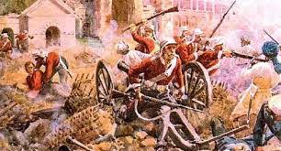
From the time of the mutineers’ seizure of Delhi, the British operations to suppress the mutiny were divided into three parts. First came the desperate struggles at Delhi, Kanpur, and Lucknow during the summer; then the operations around Lucknow in the winter of 1857–58, directed by Sir Colin Campbell; and finally the “mopping up” campaigns of Sir Hugh Rose in early 1858. Peace was officially declared on July 8, 1859.
British officialdom in Delhi had received no advance warning of the catastrophe that befell them. At 8 a.m. on Sunday, May 10, a signals officer in Meerut had been barely able to send off one terse message to the signal officer on duty in Delhi before the link ceased to function. The Delhi signaler had reported only that the 3rd Native Light Cavalry was being punished for its mass refusal to use the new cartridges (many Indians still refused to believe that the British were not greasing them with cow and pig fat), adding ominously that further particulars would be sent at 4 that afternoon. When no second message was received that day from Meerut, the signal officer left his post and crossed the Jumna River to inspect the wire line for breaks. While pacing the line, he encountered advance units of the 3rd dashing toward Delhi. They killed him instantly, but his Indian assistant escaped and returned to report the tragedy. He brought the alarming news that the 3rd Cavalry, in a state of mutiny, was about to attack Delhi.
Before being forced by mutineers to flee their office in Delhi, two signalmen managed to get off a brief warning of the disaster to Umballa late in the afternoon. Details of what had happened in Meerut did not come until later. The signalers were able to report only that Europeans ‘had been killed’ before they signed off with the cryptic sentence, ‘We must shut down.’ Umballa quickly telegraphed the electrifying news to Lahore, Rawalpindi, Peshawar in the Punjab and to a few other British cantonments in northern India, thus spreading word of the upheaval. One of the signalers was finally able to regain access to his office and send a few more details of the terrible events happening in Delhi before being discovered and captured by the mutineers. Luckily, he managed to escape and made his way to Umballa on foot to deliver a report in person.
Bahadur Shah was hesitant to accept titular leadership of the uprising. It would mean exchanging a peaceful life that permitted him to write poetry in his luxurious palace for a life promising only risk and turmoil. But he had no choice — he was, in effect, a prisoner of the mutineers. The 3rd Cavalry, now running wild in Delhi, would inevitably be joined by all native units in northern India, he was told.
For the moment the native regiments in Delhi — the 38th, 54th and 74th, plus a battery of native artillery — continued to take orders from their British officers, realizing perhaps that British reinforcements were on the way and the rebellion would soon fail. The 38th had been entrusted to guard the critical Kashmir Gate to the city. But the spectacle of the 3rd Cavalry from Meerut rampaging through the streets and killing Englishmen incited the 38th to open the gates and join their brothers in revolt. Some 150 troops from the 74th Native Infantry joined men of the 54th, who were taking the brunt of the attack, and tried to restore discipline at the Kashmir Gate. By afternoon, however, the gate had become untenable.
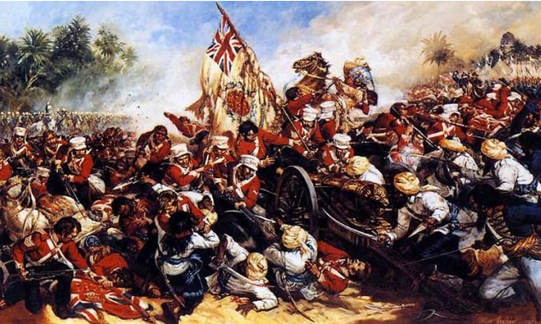
A grim feature of the mutiny was the ferocity that accompanied it. The mutineers commonly shot their British officers on rising and were responsible for massacres at Delhi, Kanpur, and elsewhere. The murder of women and children enraged the British, but in fact some British officers began to take severe measures before they knew that any such murders had occurred. In the end the reprisals far outweighed the original excesses. Hundreds of sepoys were bayoneted or fired from cannons in a frenzy of British vengeance (though some British officers did protest the bloodshed).
On the morning of the 11th, as the 3rd Cavalry invested the city, Delhi magistrate Theophilus Metcalf warned Lieutenant George Willoughby, the officer in charge of the main munitions magazine in Delhi, to take all possible steps to keep the magazine from falling into the hands of the mutineers. Willoughby did what he could to make the arsenal defensible, but he knew he did not have the force to fully defend it. With his small staff of British officers, he prepared charges so that he could blow up the arsenal rather than let the mutineers take it, knowing full well that he and his officers would probably be killed by the explosion.
The sepoys were not long in laying siege to the arsenal. At 4 p.m., Willoughby gave the order to ignite the vast piles of explosives. A shattering explosion informed the British that Delhi was lost. While the arsenal’s destruction deprived the insurgents of one supply of munitions, another magazine, located three miles outside the city and filled with some 3,000 barrels of gunpowder, had fallen into the hands of the mutineers and would keep them well-supplied. Miraculously, Willoughby and two of his officers had survived the blast and were able to reach British lines.
Watching from his command post on the Delhi Ridge, Brigadier Graves could see below him the damage caused by the arsenal’s explosion. But more worrisome than the loss of munitions was the effect the explosion had on the native troops, who were incited to even greater fury. Lieutenant Edward Vibart of the 54th Native Infantry, witness to this tableau of horror, later described it: ‘The horrible truth now flashed on me — we were being massacred right and left, without any means of escape! I made for the ramp which leads from the courtyard to the bastion above….Everyone appeared to be doing the same…the bullets whistled past us like hail. To this day it is a perfect marvel to me how any one of us escaped being hit.’

But some did escape. Under the broiling sun, the survivors of the Kashmir Gate massacre waded through streams and braved jungles in their efforts to find a safe haven. A few of the survivors sought temporary refuge within the Flagstaff Tower, where conditions were cramped and soon became unbearable. A Dr. Batson of the 74th, with Graves’ permission, struck out for Meerut on foot to plead for a relief column. Disguised as a native fakir, he finally reached Meerut after 25 days on the road. Twice Batson was caught and recognized as an Englishman despite his native dress, but he managed to talk his way out of trouble.
Having given Batson up for dead, Graves was convinced by J.A. Tytler of the 38th that his sepoys were reliable and permitted him to attempt to evacuate the women and children trapped on the ridge. The little caravan of rickety carriages was mercilessly harassed by the natives as it wended its way to safety, but finally Tytler and his charges reached Karnal. The rapid spread of the mutiny in North India provoked unprecedented anguish and indignation in Britain. Army reinforcements were rushed from Rangoon, Ceylon and the Madras Presidency in South India. The British regarded Delhi as particularly important for symbolic and strategic reasons. If it was not soon retaken, the Punjab and Northwest provinces might be encouraged to revolt. Sixteen years earlier, during the First Afghan War, the Afghans had wiped out a British army — and with it the myth of British invulnerability. And only a year had passed since the Crimean War had dramatized the rivalry between Great Britain and Russia, reminding many Indians as well as Persians and Afghans that the great Russian bear to the north could still be played off against imperial Britain’s lion. Now the only sources of quick relief for Delhi were the Punjab and northern cantonments, where there were British regiments and relatively reliable native units.
The 75th (Stirlingshire) Highlanders and the 1st and 2nd Bengal Fusiliers, which were posted near the hill station of Simla, reached Umbala on May 23 to stage an assault on Delhi. Those units were joined by the 9th Light Cavalry and 60th Rifle regiments and a squadron of the 4th Irregular Cavalry, as well as two troops of the Horse Artillery, to make up two brigades under the command of Maj. Gen. Sir Henry Barnard. From Meerut came a column consisting of one wing of the 60th Rifles, two squadrons of the 6th Dragoon Guards, 50 troopers from the 4th Irregulars, two companies of native sappers and Scott’s battery of 18-pounders — all under the command of Colonel Archdale Wilson.
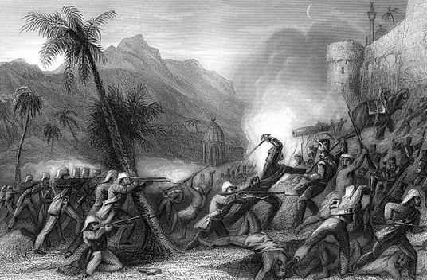
Mutineers intercepted and engaged the Meerut units some 15 miles from Delhi near a village named Ghazi-ed-din, but the mutineers were routed and kept at a safe distance. On June 7, Wilson’s Meerut column moved up to Alipore with Barnard’s two brigades from the north and attacked sepoy insurgents at Baduli-ke-Serai, five miles from Delhi. The mutineers had established an artillery battery at Baduli-ke-Serai, but a bayonet charge by the 75th Highlanders overran the position on June 8. The combined British columns, known as the Army of Retribution, then retook the strategically important Delhi Ridge, extending from the Flagstaff Tower south to the house of the late Rajah Hindu Rao. The Army of Retribution was soon joined by other units arriving from the hill stations north of Delhi and the Punjab, many of whom had covered the distance of more than 500 miles in a record 22 days.
In searing heat that sometimes reached 140 degrees, the British held off repeated efforts by the mutineers to retake the ridge. Intelligence reports reaching the British suggested a growing schism between Muslim and Hindu mutineers in Delhi. But whatever disputes may have divided the sepoys, retaking a fortified Delhi, whose forces far outnumbered the British, would not be an easy task. Barnard, commanding the ridge force, was reluctant to attack the entrenched positions of the mutineers without further reinforcements, including a proper siege train.
June 23, the 100th anniversary of Robert Clive’s victory at the Battle of Plassey, which had marked the completion and consolidation of the British East India Company’s control over India, was a difficult day for the British. On this day, bazaar folklore had it, the British Raj would be driven from the subcontinent. In what may have been an attempt to fulfill that prophecy, the sepoys launched a particularly savage attack on the ridge. The British won the day, however, driving the attackers back to their Delhi ramparts.
Adding to the difficulties of the British was Barnard’s sudden death on July 5 from cholera, a virulent disease that took a heavy toll on many of the ridge defenders. Major General Thomas Reed replaced Barnard, but he was too ill to command and was replaced a fortnight later. Given the temporary rank of major general, Archdale Wilson took command of a force now consisting of 4,023 infantrymen, 1,293 cavalrymen, and 1,602 artillerymen and engineers — a total of 6,918 effective troops, but still no match for the enemy behind Delhi’s walls.
Brigadier General John Nicholson’s flying column, which had dashed down the Grand Trunk high road from the Punjab to Delhi’s relief, arrived to join the British forces on Delhi Ridge in mid-August. The striking-looking, 6 foot 2 inch Irishman had served with distinction for 20 years, and his legendary reputation inspired all who fought under his command. A native cult that revered Nicholson had even arisen in the Northwest Frontier area and northern Punjab. An admiring lady described his magnetism: ‘He could put his own heart into a whole camp and make believe it was its own.’
Nicholson’s arrival with his badly needed force was none too soon. The soldiers, riddled with cholera, were beginning to feel inadequate for the challenge awaiting them. There were, moreover, rumors of treachery in the native ranks and suspicions that in combat some sepoys had shot at their British officers from behind. A few native regiments were, in fact, dismissed from duty and sent off the ridge on suspicion of harboring rebellious intentions.
Nicholson was so concerned about the state of affairs on Delhi Ridge that, on September 7, he wrote the chief commissioner in the Punjab, Sir John Lawrence, ‘Wilson’s head is going; he says so himself, and it is quite evident he speaks the truth.’ Lawrence then wrote to Wilson, reminding him that the fate of the British throughout India demanded an immediate assault on Delhi. The commissioner understood that if the campaign failed, even the Sikhs would falter in their loyalty. Northwest India would rise, and the tragedy of the First Afghan War would be re-enacted on the flat plains of the Punjab. The eminent Lord Frederick Roberts later reminisced about an extraordinary talk he had with Nicholson during those tense days. The fierce-eyed warrior had said with uncommon conviction: ‘Delhi must be taken and it is absolutely essential that this should be done at once; and if Wilson hesitates longer, I intend to propose at to-day’s meeting that he should be superseded.’
As it turned out, on that day Wilson did order preparations for an assault to begin in earnest. The plan of attack called for General Nicholson to lead a 1,000-man column from the 75th Highlanders to mount the Kashmir Bastion, while another column from the 52nd (Oxfordshire & Buckinghamshire) Light Infantry would force the Kashmir Gate, enabling the British troops to fight their way into the city itself. Other columns would breach the Lahore Gate. A total of 5,000 men would take part in the British assault on Delhi, whose estimated 30,000 sepoy defenders were now under the command of Bakht Khan, an artillery officer who had 40 years of military experience.
The attack was scheduled for 3 a.m. on September 14. ‘There was not much sleep,’ wrote one officer in a letter home that evening. ‘Just after midnight we fell in as quickly as possible, and by the light of a lantern the orders for the assault were read to the men. Any man who might be wounded was to be left where he fell.’ The Roman Catholic Chaplain Bertrand blessed the 75th Highlanders and prayed for mercy ‘on the souls of those soon to die.’
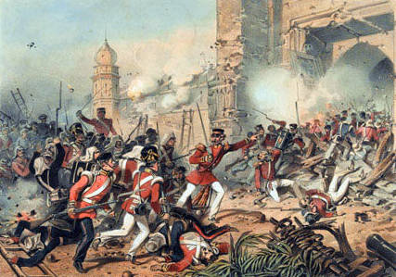
Nicholson signaled his column to charge. An earsplitting shout from the 60th Rifles was met by flame-belching rebel artillery. But not all went well. Nicholson’s storming party outran its ladder-bearers and was left exposed in the 16-foot moat, where they were raked by withering fire from the mutineers on the walls above them. When the ladder parties caught up with them, Nicholson led the survivors in a charge through a breach that had been made in the wall by his supporting artillery.
Colonel George Campbell rushed his column to within striking distance of the critical Kashmir Gate and sent a small party of Bengal Engineers, under Lieutenant Duncan Home, to pack explosives under the gate. A firing party of the 52nd covered them as best it could, but the exposed sappers drew terrible fire. Half of them were killed and Lieutenant Philip Salkeld was mortally wounded, but Sergeant John Smith finally managed to touch off the explosion that blew a hole in the gate. As Bugler Robert Hawthorne of the 52nd sounded the attack, the British troops poured through the opening to be met only by the charred corpses of the sepoy defenders. Home, Salkeld, Hawthorne and Smith later received the Victoria Cross for the part they played in blowing open the Kashmir Gate; Salkeld’s was the first VC to be awarded posthumously.
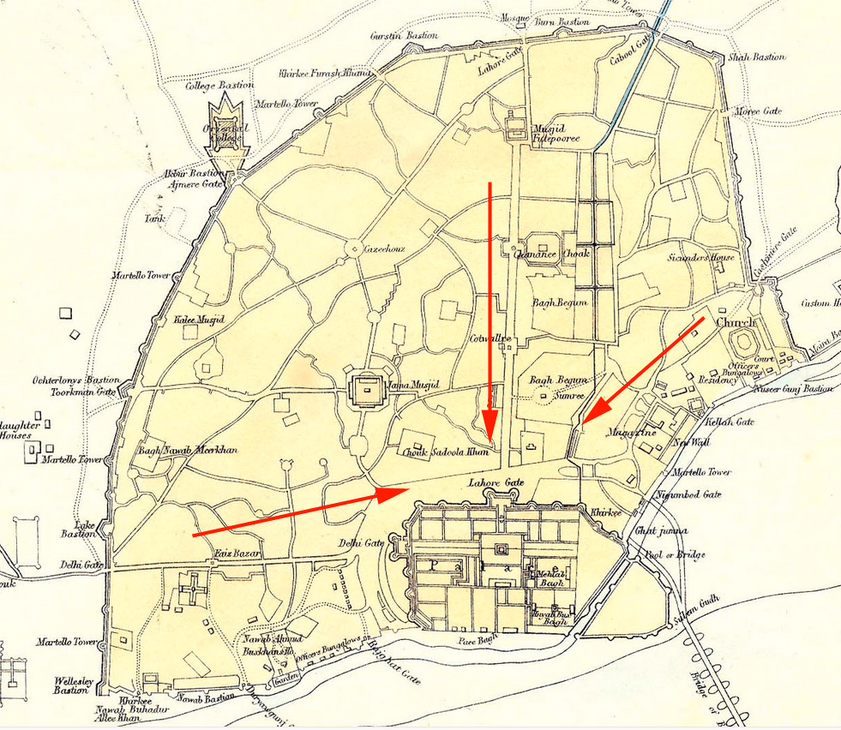

Delhi City
Now within the city gates, three columns joined forces in an area between the Kashmir Gate and the Anglican church. The fourth column, whose artillery failed to appear amid the confusion, had been forced to retreat beyond the field of fire due to heavy casualties. The troops within the Kashmir Gate had to make their way some 250 yards down a 10-foot-wide lane flanked by flat-topped buildings, from which sepoys maintained a constant rain of fire. Making matters worse were two artillery pieces at the head of the lane and some 1,000 mutineers waiting to fire on the approaching British from atop the so-called Burn Bastion.
The 1st Bengal Fusiliers took the lead in making the dash up the lane toward the Lahore Gate, which had to be opened to admit other British units. Powerless against the sheets of rifle fire from the rooftops, the fusiliers fell back. Nicholson then personally led a new attack on the Lahore Gate. Just as he flourished his saber, however, a mutineer fired on him point-blank from a window. Badly wounded, he mustered the strength to prop himself up on one elbow and once again shouted encouragement to his men,
but his troops were unable to force this death trap and had to retire. In six hours, the British had lost 66 officers and 1,104 men.
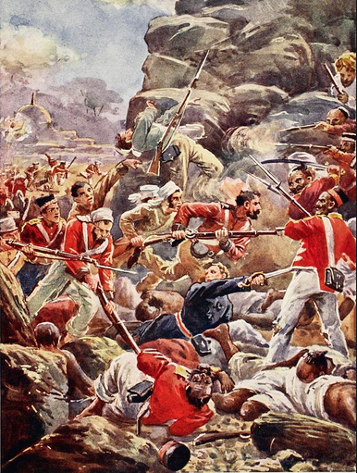
The fight for the city continued in the face of the massed sepoys entrenched beyond the British foothold on the northern extremity of the city. The situation looked hopeless to almost everyone — except Nicholson, who fought for life as he rested near the Kashmir Gate. Sensing that Wilson was again losing heart, Nicholson was said to have muttered, ‘Thank God I have strength yet to shoot him if necessary.’
Ranking officers such as Colonel Richard Baird Smith, Wilson’s chief engineer, and Brig. Gen. Neville Chamberlain prevailed upon Wilson to keep up the struggle for Delhi. On September 16, the magazine that Willoughby had blown up was captured. To the delight of the British, some 171 guns and vast stores of ammunition had somehow escaped damage in the explosion. The narrow lane leading to the Lahore Gate was widened and made navigable by blasting the houses along its curbs. On September 19, the Burn Bastion was taken, and on the following day the Lahore Gate finally fell to the British. As the weary days of fighting continued, news of victories was welcome. News of Nicholson’s ebbing life was not. When the great soldier died, he was widely mourned and has ever since rested securely in the British pantheon of war heroes. The last remaining redoubt of the sepoys was believed to be the king’s palace, but when its gates were blown open, it was found to be nearly deserted. At dawn on September 21, a royal salute told all within hearing distance that Delhi had been taken by the Army of Retribution. The seat of the once-great Mogul Empire was forever gone.
Bahadur Shah, disillusioned and tired of being manipulated by the sepoys, had hidden a few miles north of the city in Emperor Homayun’s tomb. This was discovered by the intrepid but headstrong Major William Hodson, who was famous along the Northwest Frontier as the leader of hard-riding irregulars known as Hodson’s Horse and who now managed intelligence for the British at Delhi. With 50 of his men he set out on September 21 to bring in the errant king.
Bahadur Shah had huddled inside the cloisters of the tomb while thousands of his servants and well-wishers sullenly watched the approaching British horsemen. The king knew that resistance on his part would be pointless, and he accepted Hodson’s promise that the major would spare his life if he gave up quietly.
Followed by a vast entourage of Indians, Hodson led his captive back to Delhi. Then, he and 100 of his irregular cavalrymen returned to Homayun’s tomb, this time to bring back the king’s two sons and grandson. Despite a mob of royal retainers and partisans, many of whom were armed, Hodson was able to flush the young scions of the Mogul dynasty from their hiding place. Hodson, surrounded by a hostile crowd, did something that has ever since been criticized but may have saved his life and those of his escort — he raised his carbine and summarily executed the three princes. Amazingly, the shocked mob did nothing. Hodson, as he had done many times before, stunned his adversaries into submission by sheer audacity. The bodies were dumped unceremoniously at the spot where the king’s sons were thought to have committed atrocities against the English. As the British chaplain observed, ‘It was a dire retribution.’
Bahadur, humiliated by a trial, exiled for life in Rangoon and saddened by the death of his sons and grandson, described his feelings in a poem he wrote before his death on November 7, 1862: ‘All that I loved is gone/Like a garden robbed of its beauty by Autumn/I am only a memory of splendor.’
This article was written by John H. Waller and originally published in the March 1998 issue of Military History. For more great articles be sure to subscribe to Military History magazine today!

Aftermath
The immediate result of the mutiny was a general housecleaning of the Indian administration. The East India Company was abolished in favour of the direct rule of India by the British government. In concrete terms, this did not mean much, but it introduced a more personal note into the government and removed the unimaginative commercialism that had lingered in the Court of Directors. The financial crisis caused by the mutiny led to a reorganization of the Indian administration’s finances on a modern basis. The Indian army was also extensively reorganized.
Another significant result of the mutiny was the beginning of the policy of consultation with Indians. The Legislative Council of 1853 had contained only Europeans and had arrogantly behaved as if it were a full-fledged parliament. It was widely felt that a lack of communication with Indian opinion had helped to precipitate the crisis. Accordingly, the new council of 1861 was given an Indian-nominated element. The educational and public works programs (roads, railways, telegraphs, and irrigation) continued with little interruption; in fact, some were stimulated by the thought of their value for the transport of troops in a crisis. But insensitive British-imposed social measures that affected Hindu society came to an abrupt end.
Finally, there was the effect of the mutiny on the people of India themselves. Traditional society had made its protest against the incoming alien influences, and it had failed. The princes and other natural leaders had either held aloof from the mutiny or had proved, for the most part, incompetent. From this time all serious hope of a revival of the past or an exclusion of the West diminished. The traditional structure of Indian society began to break down and was eventually superseded by a Westernized class system, from which emerged a strong middle class with a heightened sense of Indian nationalism.
Quick Facts
date
- May 10, 1857 - July 8, 1859
location
- Agra
- Delhi
- India
- Kanpur
- Lucknow
participants
- Mughal dynasty
- United Kingdom
context
- British Empire
- Western colonialism
- East India Company
- British raj
key people
- Charles John Canning, Earl Canning
- Colin Campbell, Baron Clyde
- Sir Henry Havelock
- Lakshmi Bai
- Nana Sahib
- Robert Napier, 1st Baron Napier
- Hugh Henry Rose, Baron Strathnairn of Strathnairn and of Jhansi
- Tantia Tope
- William Stephen Raikes Hodson
- Mangal Pandey
major events
- Siege of Lucknow
- Siege of Delhi
related topics
- Enfield rifle
- Doctrine of lapse
- Westernization

HistoryNet.com is brought to you by World History Group, the world's largest publisher of history magazines. HistoryNet.com contains daily features, photo galleries and over 5,000 articles originally published in our various magazines.
- https://www.facebook.com/HistoryNet/
- https://twitter.com/HistoryNet
- https://www.youtube.com/channel/UCzdWdL_xC5qk07WWOtnXSWA
- https://www.instagram.com/historynetdotcom/
- https://www.britannica.com/event/Indian-Mutiny
© 2018 HistoryNet
http://www.historynet.com/indian-mutiny-of-1857-siege-of-delhi.htm

